|  |
| --- |
| EJERCICIOS NIVEL: 0 |

|  |  |  |  |  |  |  |
| --- | --- | --- | --- | --- | --- | --- |
| N0_L3_E1 | N0_L4_E1 | N0_L4_E2 | N0_L4_E3 | N0_L8_E1 | N0_L8_E2 | N0_L8_E3 |

|  |  |  |  |  |  |  |  |  |  |  |  |  |  |
| --- | --- | --- | --- | --- | --- | --- | --- | --- | --- | --- | --- | --- | --- |
| 1 | 1.68 | 1 | 1.66 | 1 | 1.73 | 1 | 1.46 | 1 | 1.66 | 2 | 2.32 | 1 | 1.86 |



N0_L3_E1



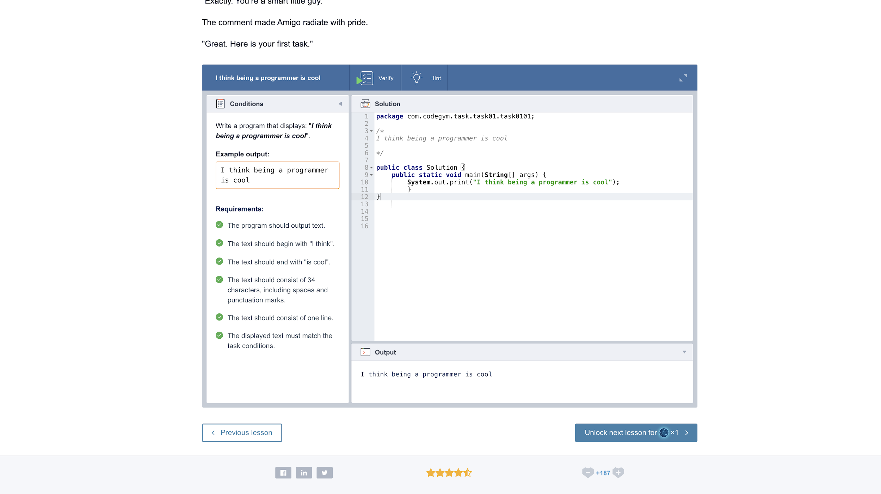

N0_L4_E1

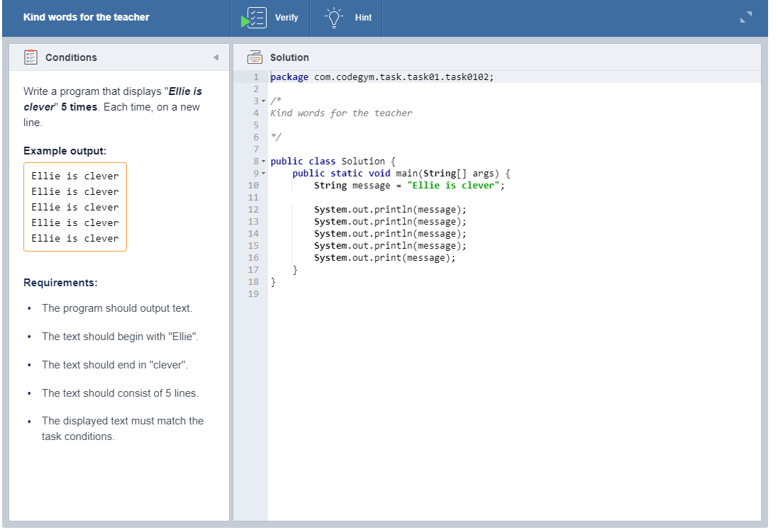

N0_L4_E2



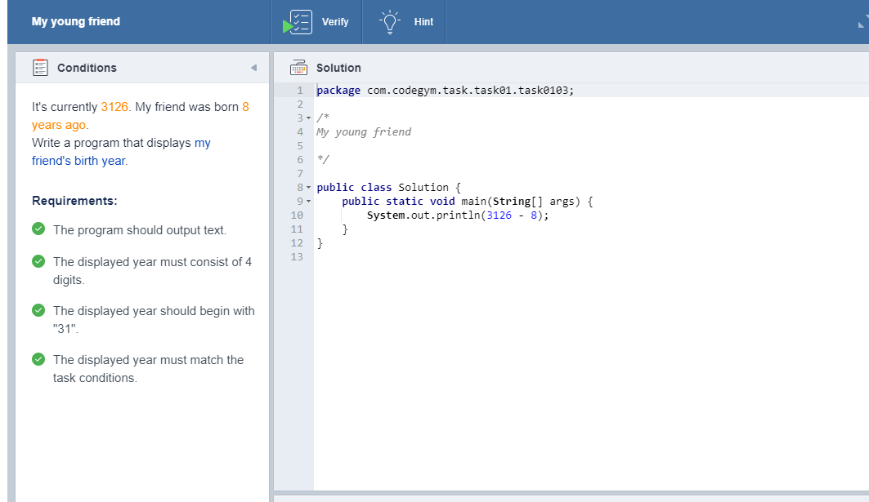

N0_L4_E3



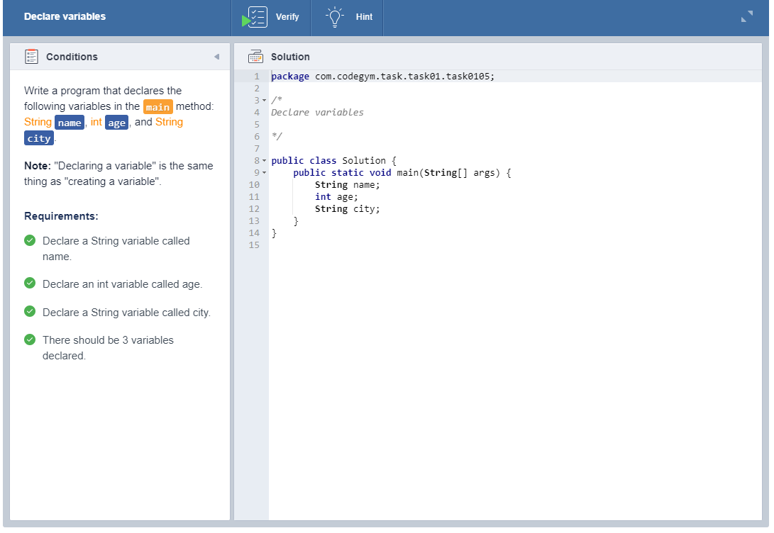

N0_L8_E1



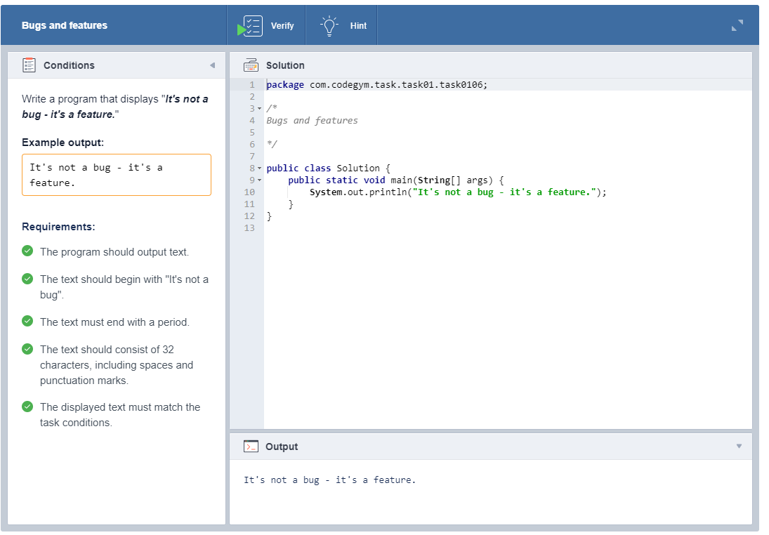

N0_L8_E2



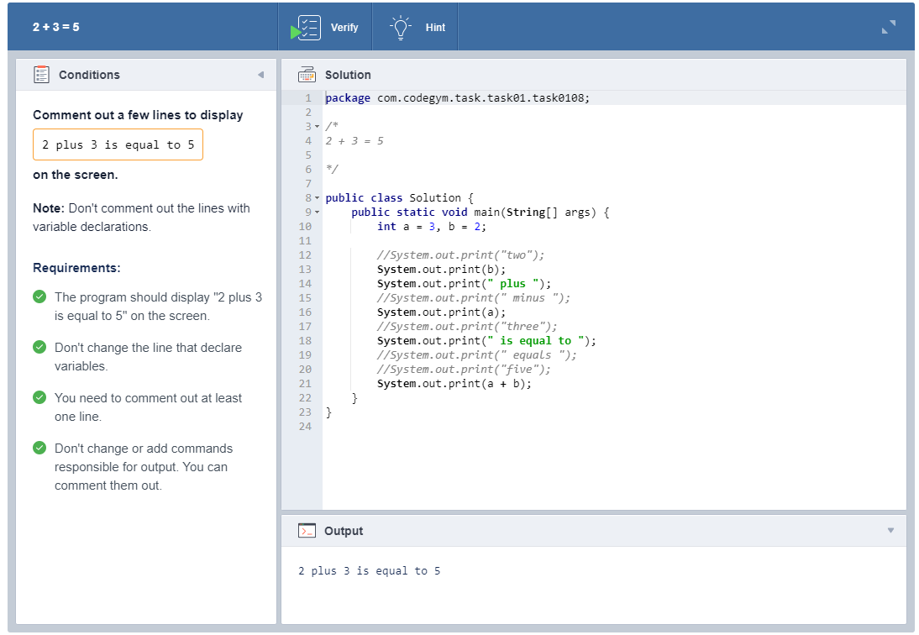

N0_L8_E3



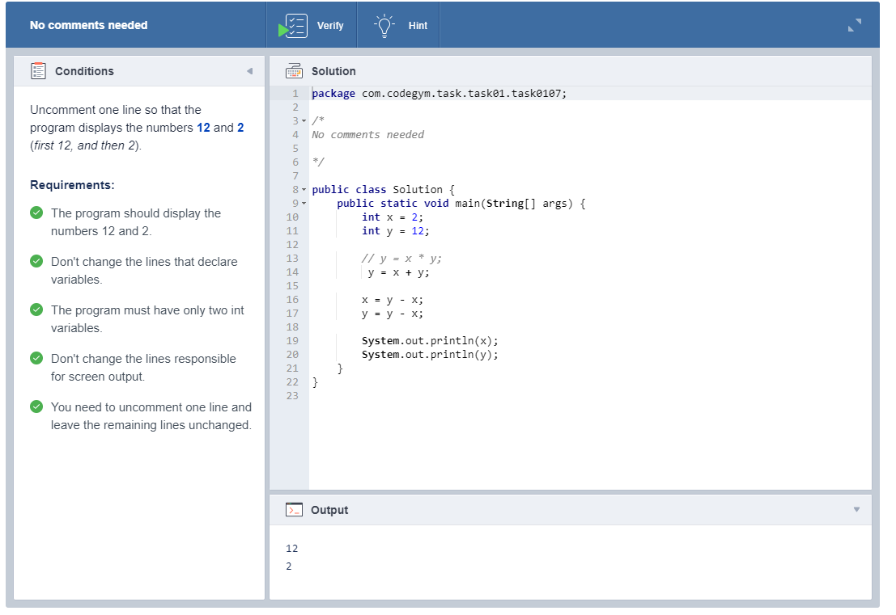

LOGROS

